Assignment 7
Exercise 1)
Step A
Use the TestDataGen program from previous assignments to generate new data files
Copy the files to HDFS.
Magic Number = 193400
[maria_dev@sandbox-hdp ~]$ hadoop fs -put /home/maria_dev/foodratings193400.txt /user/maria_dev/foodratings193400.csv

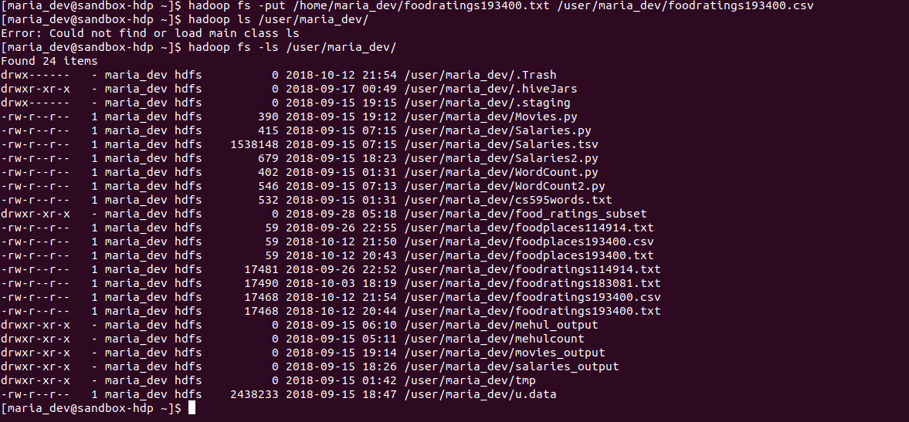
Step B
Load the ‘foodratings’ file as a ‘csv’ file into a DataFrame called ex1_foodratings. When doing so specify a schema having fields of the following names and types:
Field Nampee | Field Type
name | String
food1 | Integer
food2 | Integer
food3 | Integer
food4 | Integer
placeid | Integer

As the results of this exercise provide the magic number, the code you execute and screen shots of the following commands:
foodratings.printSchema()
foodratings.head(5)

Pyspark code:
[maria_dev@sandbox-hdp ~]$ vi assign_7_q2.py
from pyspark.sql.types import *
struct1 = StructType().add("placeid", IntegerType(), True).add("placename",StringType(), True)
foodplaces = spark.read.schema(struct1).csv('/user/maria_dev/foodplaces193400.csv')
foodplaces.printSchema()
print foodplaces.head(5)
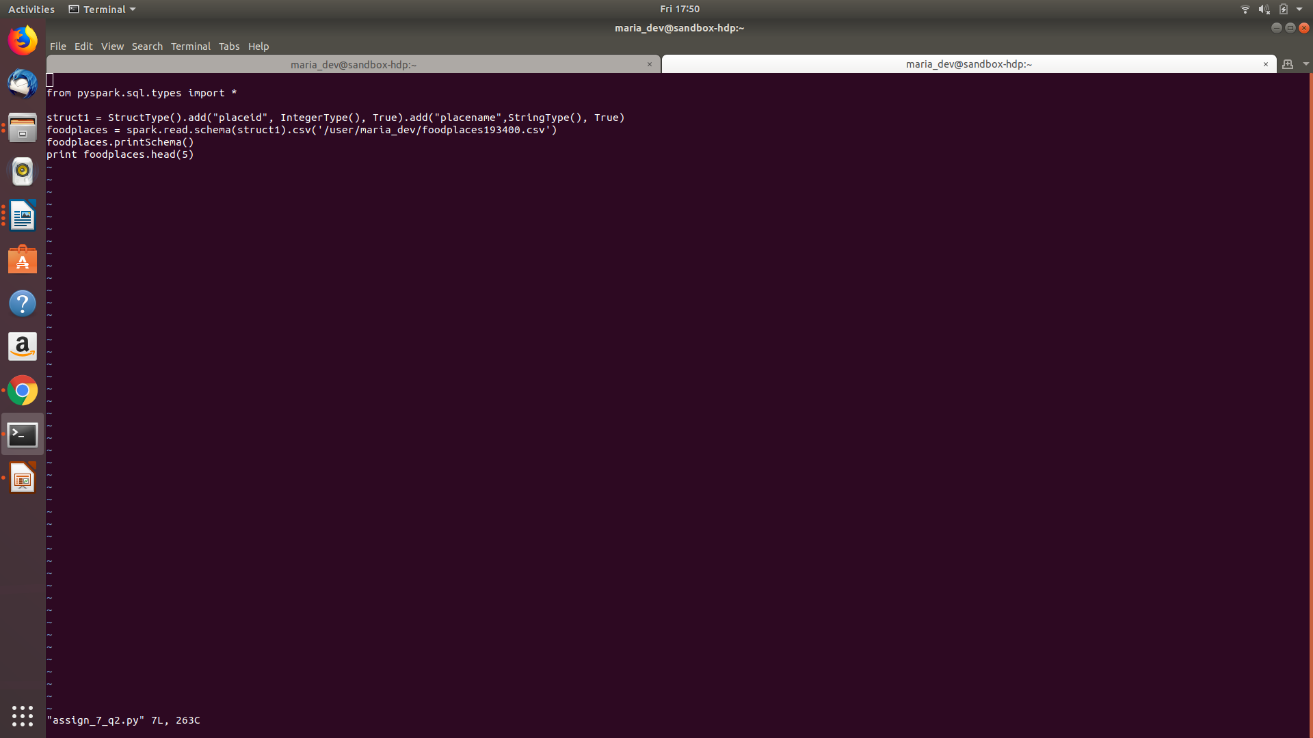
Command:
>>> execfile('/home/maria_dev/assign_7_q2.py')

Exercise 2)
Load the ‘foodplaces’ file as a ‘csv’ file into a DataFrame called foodplaces. When doing so specify a schema having fields of the following names and types:
Command:
[maria_dev@sandbox-hdp ~]$ hadoop fs -put /home/maria_dev/foodplaces193400.txt /user/maria_dev/foodplaces193400.csv
Field Nampee | Field Ty
placeid | integer
placename | string

As the results of this exercise provide the code you execute and screen shots of the following commands:
foodratings.printSchema()
foodratings.head(5)
Pyspark code :
rom pyspark.sql.types import *
struct1 = StructType(
[
StructField("name", StringType(), True),
StructField("food1",IntegerType(), True),
StructField("food2",IntegerType(), True),
StructField("food3",IntegerType(), True),
StructField("food4",IntegerType(), True),
StructField("placeid",IntegerType(), True)
]
)
foodratings = spark.read.schema(struct1).csv('/user/maria_dev/foodratings193400.csv')
foodratings.printSchema()
print foodratings.head(5)
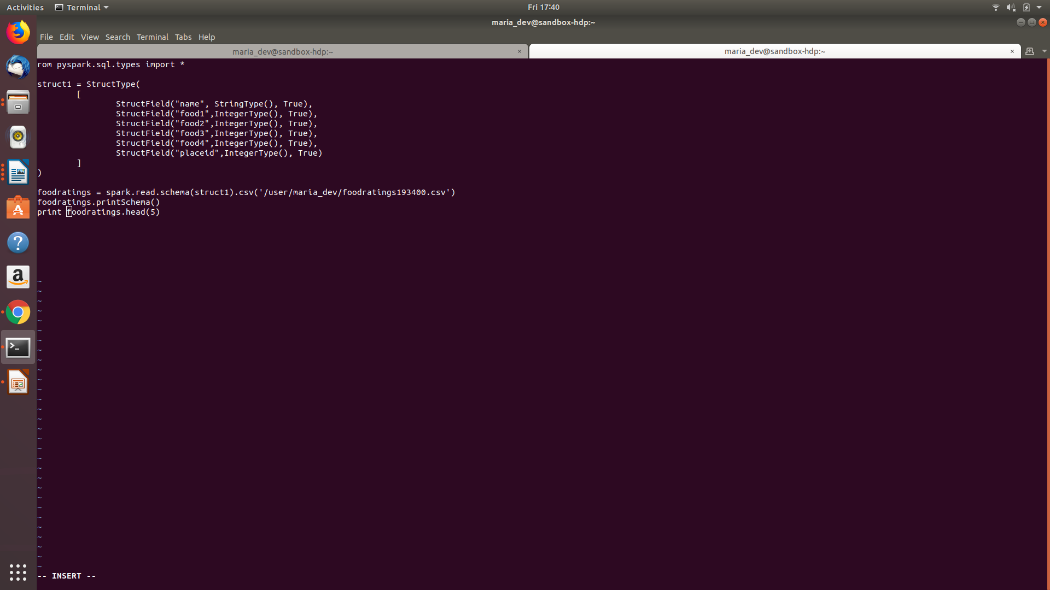
Command:>>> execfile('/home/maria_dev/assign_7_q1.py')
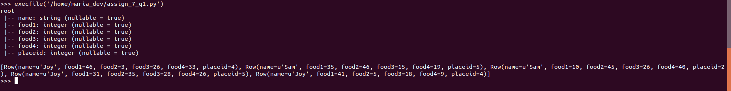

Exercise 3)
Step A
Register the DataFrames created in exercise 1 and 2 as tables called “foodratingsT” and “foodplacesT”
Step B
Use a SQL query on the table “foodratingsT” to create a new DataFrame called foodratings_ex3 holding records which meet the following condition: food2 < 25 and food4 > 40
As the results of this step provide the code you execute and screen shots of the following commands:
foodratings.printSchema()
foodratings.head(5)

Step C
Use a SQL query on the table “foodplacesT” to create a new DataFrame called foodplaces_ex3 holding records which meet the following condition: placeid > 3
As the results of this step provide the code you execute and screen shots of the following commands:
foodratings.printSchema()
foodratings.head(5)
Pyspark code :
[maria_dev@sandbox-hdp ~]$ vi assign_7_q3.py
from pyspark.sql.types import *
structfr = StructType(
[
StructField("name", StringType(), True),
StructField("food1",IntegerType(), True),
StructField("food2",IntegerType(), True),
StructField("food3",IntegerType(), True),
StructField("food4",IntegerType(), True),
StructField("placeid",IntegerType(), True)
]
)

structfp = StructType().add("placeid", IntegerType(), True).add("placename",StringType(), True)

foodratings = spark.read.schema(structfr).csv('/user/maria_dev/foodratings193400.csv')
foodplaces = spark.read.schema(structfp).csv('/user/maria_dev/foodplaces193400.csv')

foodratings.createOrReplaceTempView("foodratingsT")
foodplaces.createOrReplaceTempView("foodplacesT")

foodratings_ex3 = spark.sql("SELECT * FROM foodratingsT WHERE food2 < 25 AND food4 > 40")
foodratings_ex3.printSchema()
print foodratings_ex3.head(5)

foodplaces_ex3 = spark.sql("SELECT * FROM foodplacesT WHERE placeid > 3")
foodplaces_ex3.printSchema()
print foodplaces_ex3.head(5)
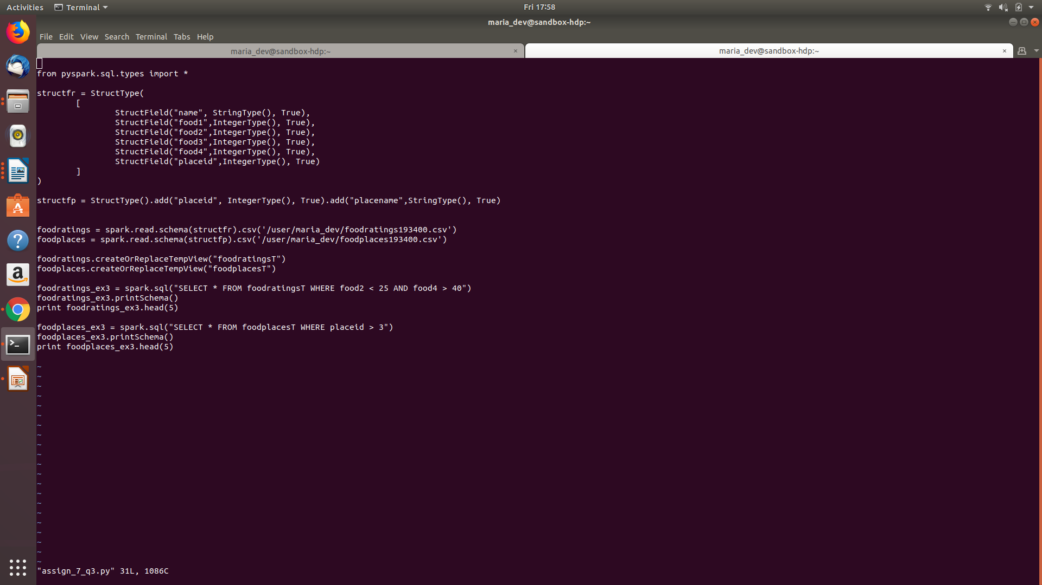
execfile('/home/maria_dev/assign_7_q3.py')
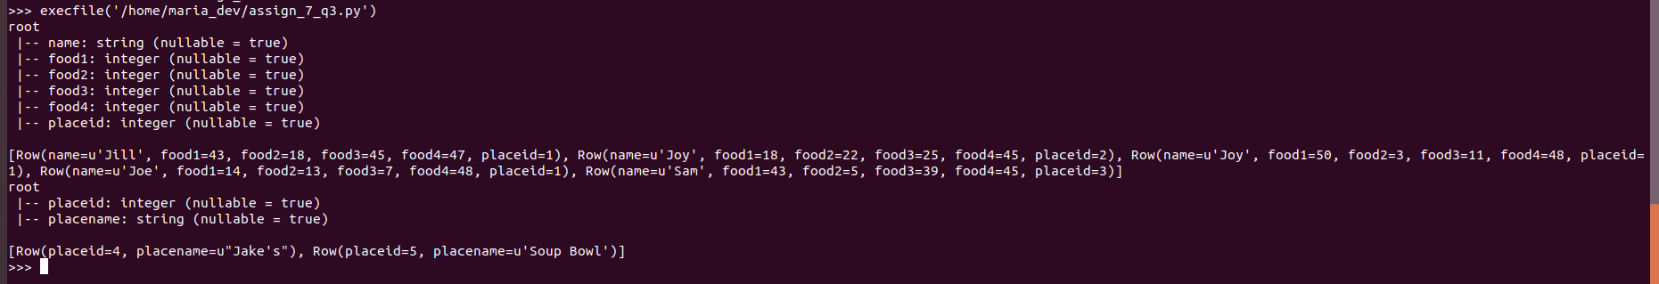
Exercise 4)
Use an operation (not a SQL query) on the DataFrame ‘foodratings’ create in exercise 1 to create a new DataFrame called foodratings_ex4 that includes only those records (rows) where the ‘name’ field is “Mel” and food3 < 25.
As the results of this step provide the code you execute and screen shots of the following commands:
foodratings.printSchema()
foodratings.head(5)
Pyspark code:
[maria_dev@sandbox-hdp ~]$ vi assign_7_q4.py
from pyspark.sql.types import *
struct1 = StructType(
[
StructField("name", StringType(), True),
StructField("food1",IntegerType(), True),
StructField("food2",IntegerType(), True),
StructField("food3",IntegerType(), True),
StructField("food4",IntegerType(), True),
StructField("placeid",IntegerType(), True)
]
)

foodratings = spark.read.schema(struct1).csv('/user/maria_dev/foodratings193400.csv')
foodratings_ex4 = foodratings.filter((foodratings['name'] == "Mel") & (foodratings['food3'] < 25))
foodratings_ex4.printSchema()
print foodratings_ex4.head(5)
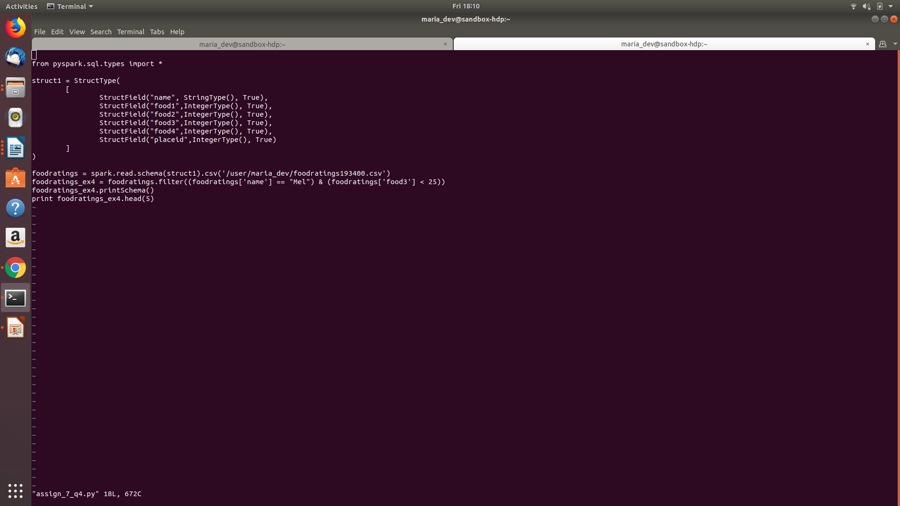
Exercise 5)
Use an operation (not a SQL query) on the DataFrame ‘foodratings’ create in exercise 1 to create a new DataFrame called foodratings_ex5 that includes only the columns (fields) ‘name’ and ‘placeid’
As the results of this step provide the code you execute and screen shots of the following commands:
foodratings.printSchema()
foodratings.head(5)
PySpark code:
[maria_dev@sandbox-hdp ~]$ vi assign_7_q5.py
from pyspark.sql.types import *

struct1 = StructType(
[
StructField("name", StringType(), True),
StructField("food1",IntegerType(), True),
StructField("food2",IntegerType(), True),
StructField("food3",IntegerType(), True),
StructField("food4",IntegerType(), True),
StructField("placeid",IntegerType(), True)
]
)

foodratings = spark.read.schema(struct1).csv('/user/maria_dev/foodratings193400.csv')
foodratings_ex5 = foodratings.select(foodratings['name'],foodratings['placeid'])
foodratings_ex5.printSchema()
print foodratings_ex5.head(5)
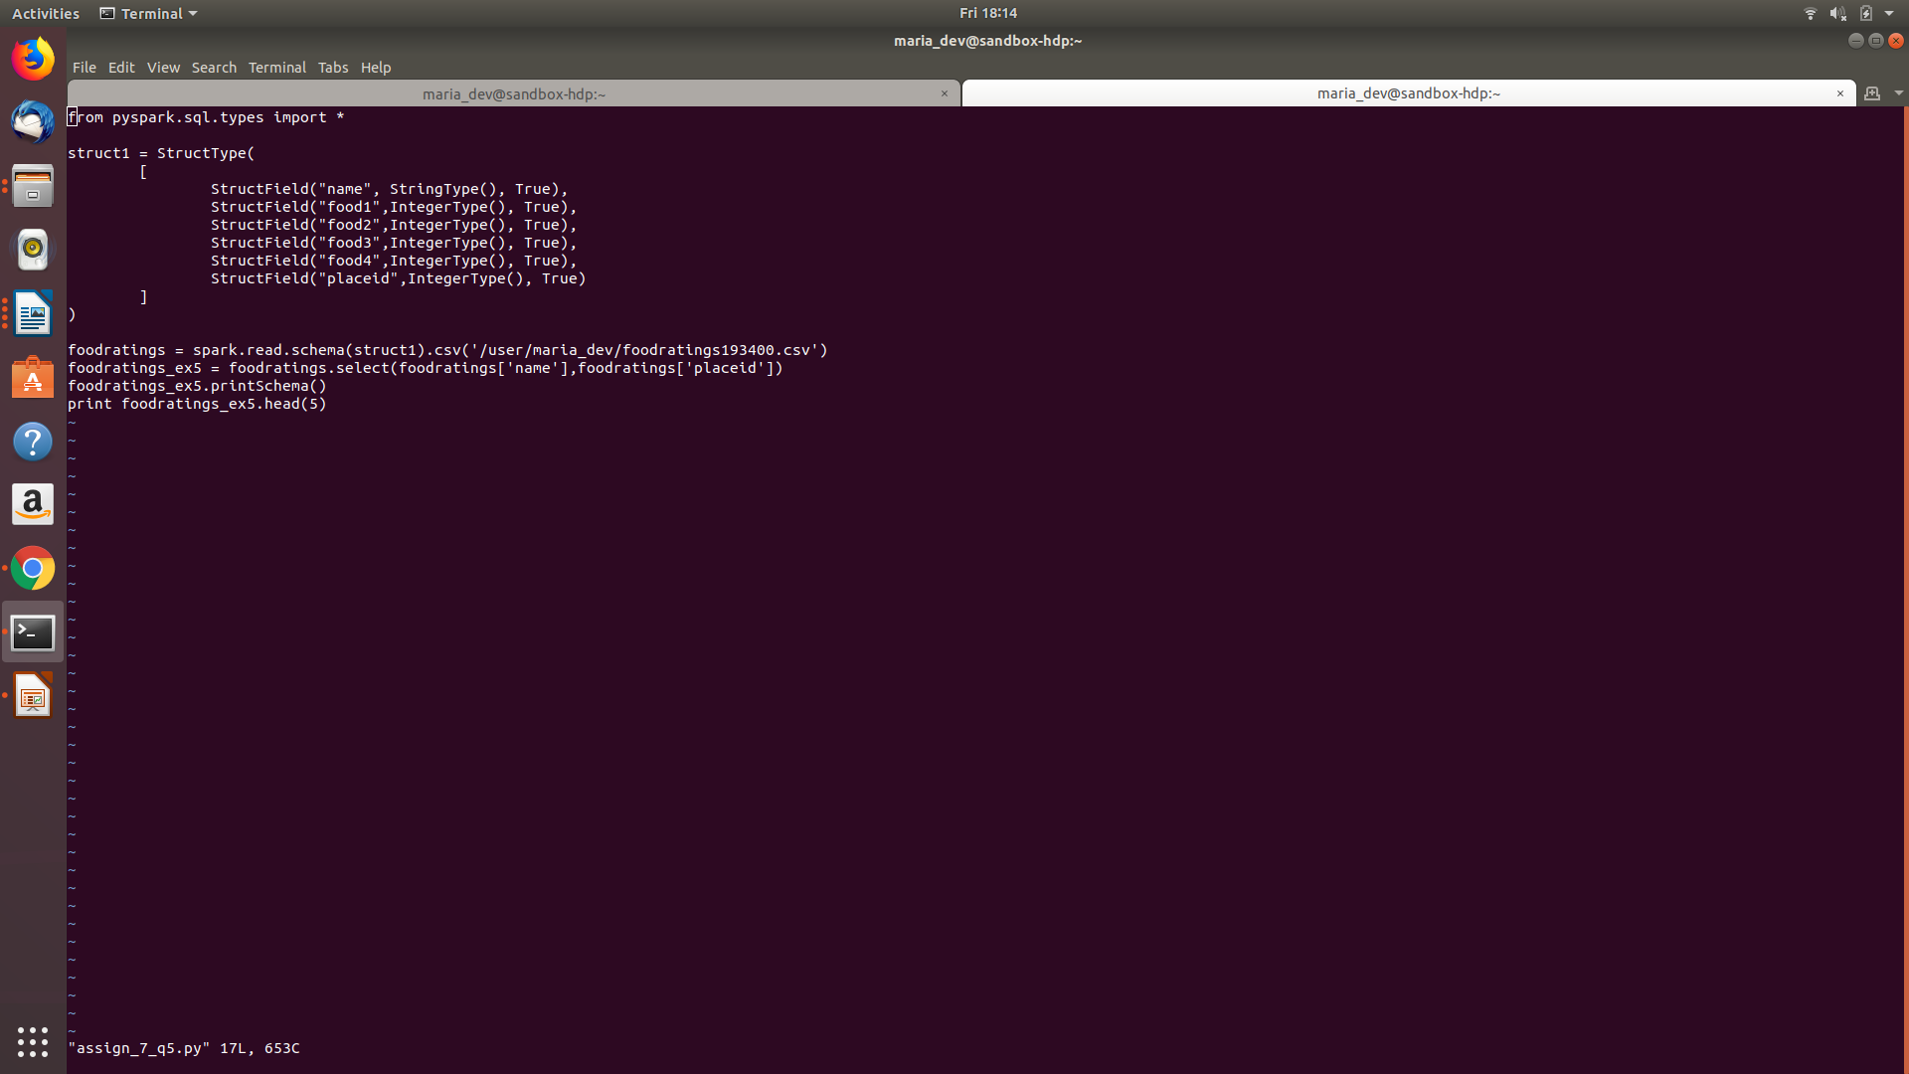
>>> execfile('/home/maria_dev/assign_7_q5.py')
Exercise 6)
Use an operation on the DataFrame ‘to create a new DataFrame called ex6 which is the inner join, on placeid, of the DataFrames ‘foodratings; and ‘foodplaces’ created in exercises 1 and 2
As the results of this step provide the code you execute and screen shots of the following commands:
ex6.printSchema()
ex6.head(5)
PySpark code :
[maria_dev@sandbox-hdp ~]$ vi assign_7_q6.py
from pyspark.sql.types import *

structfr = StructType(
[
StructField("name", StringType(), True),
StructField("food1",IntegerType(), True),
StructField("food2",IntegerType(), True),
StructField("food3",IntegerType(), True),
StructField("food4",IntegerType(), True),
StructField("placeid",IntegerType(), True)
]
)

structfp = StructType().add("placeid", IntegerType(), True).add("placename",StringType(), True)

foodratings = spark.read.schema(structfr).csv('/user/maria_dev/foodratings193400.csv')
foodplaces = spark.read.schema(structfp).csv('/user/maria_dev/foodplaces193400.csv')

ex6 = foodratings.join(foodplaces, foodratings.placeid == foodplaces.placeid, 'inner')
ex6.printSchema()
print ex6.head(5)
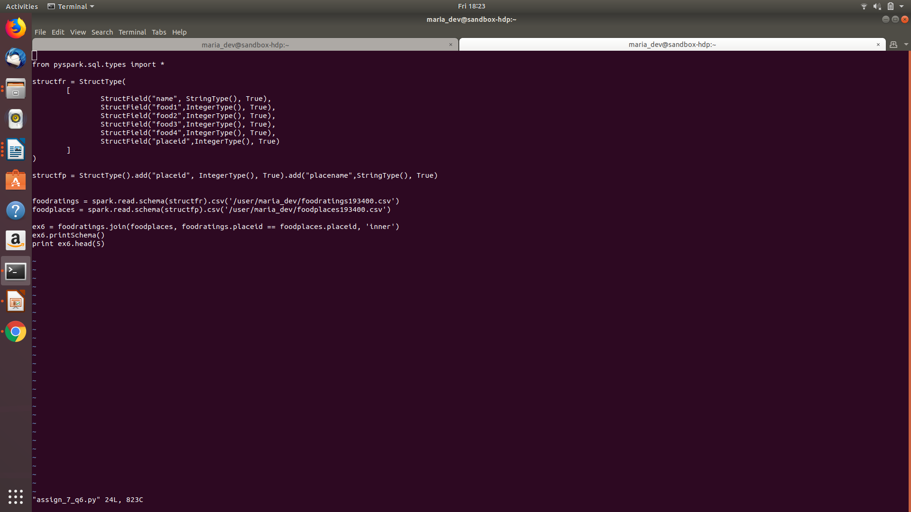
>>> execfile('/home/maria_dev/assign_7_q6.py')
